# Unit 1 - Introduction

Topics covered: Evolution of Cloud Computing, Cloud Computing Overview, Characteristics, Applications, Benefits, Challenges.

## Why Cloud?

### Before cloud computing

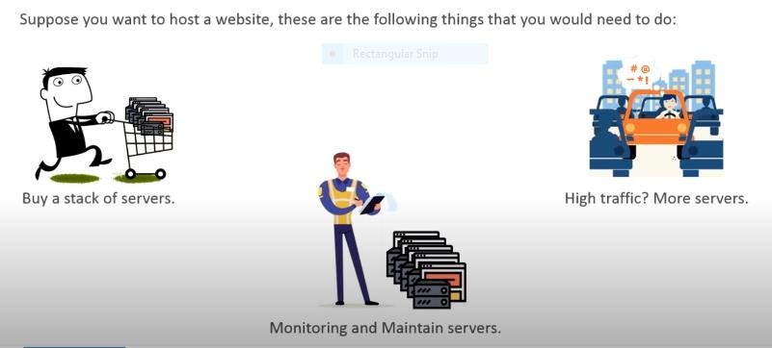

Also, you may have lots of data as shown in diagram given below:

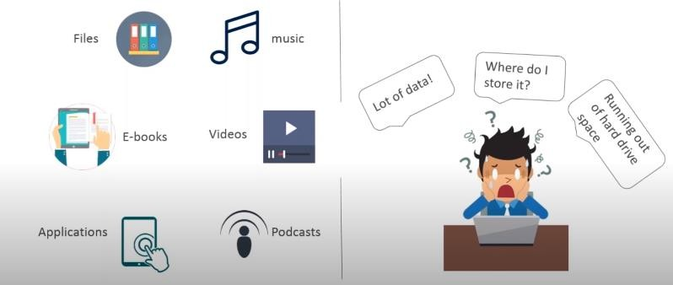

**After use of Cloud computing**

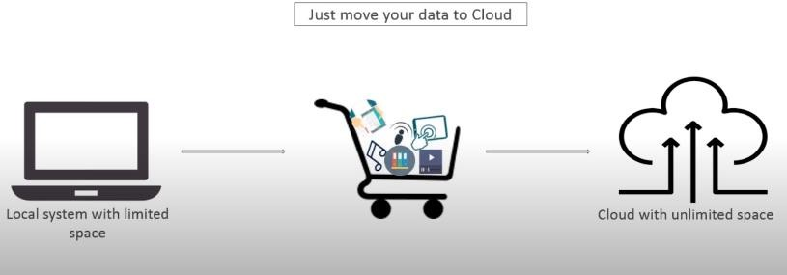

## What is Cloud Computing?

1. **Evolution of Cloud Computing**
   * The trend toward cloud computing started in the late 1980s with the concept of grid computing when, for the first time, a large number of systems were applied to a single problem, usually scientific in nature and requiring very high levels of parallel computation.
   * Since 2000, cloud computing has come into existence
   * Amazon started Amazon Web Services
   * Google released Google App Engine
   * Microsoft launched its Azure platform
   * Companies, including Google, Microsoft, Amazon, and IBM, have built enormous datacenter-based computing capacity all over the world to support Web service offerings.
   * With this computing infrastructure in place these companies are offering new cloud-based software applications.

## Cloud Computing Overview

* + Cloud Computing can be defined as delivering computing power (CPU, RAM, Network Speeds, Storage, OS, software) as a service over a network (usually on the internet) rather than physically having the computing resources at the customer location.
  + Cloud computing means on demand delivery of IT resources via the internet with pay-as-you-go pricing.
  + It provides a solution for IT infrastructure in low cost.

## Characteristics

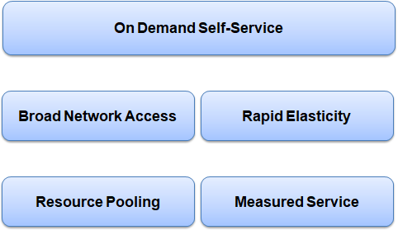

### On Demand Self-service

* + - Cloud computing provides resources on demand, i.e. when the consumer wants it.
    - Self-service means that the consumer performs all the actions needed to acquire the service himself, instead of going through an IT department.

### Broad Network Access

* + - Cloud capabilities are available over the network and accessed through standard mechanism that promote use by heterogeneous client such as mobile phone, laptop etc.

### Resource pooling

* + - The provider’s computing resources are pooled together to serve multiple customers, with different physical and virtual resources dynamically assigned and reassigned according to the customers demand.

### Rapid Elasticity

* + - Capabilities can be elastically provisioned and released to scale up and down with demand.
    - To the consumer, the capabilities available for provisioning often appear to be unlimited and can be used in any quantity at any time.

### Measured Services

* + - Cloud systems automatically control and optimize resource use by using a metering capability.
    - Resource usage can be monitored, controlled, and reported, providing transparency for both the provider and consumer of the utilized service.

## Applications

### Educational Applications

* + - Cloud computing in the education sector is very popular.
    - It offers various online distance learning platforms and student information portals to the students.

### Entertainment Applications

* + - Cloud computing offers various entertainment applications such as movies, online games, web series etc.

### Business Applications

* + - Business applications are based on cloud service providers.
    - Today, every organization requires the cloud business application to grow their business.
    - It also ensures that business applications are 24*7 available to users.

### Data Storage and Backup Applications

* + - Cloud computing allows us to store information (data, files, images, audios, and videos) on the cloud and access this information using an internet connection.
    - Various backup and recovery applications are offered for retrieving the data.

### Social Applications

* + - Social cloud applications allow a large number of users to connect with each other using social networking applications such as WhatsApp, Facebook, Twitter, Instagram, Linkedln etc.

## Benefits

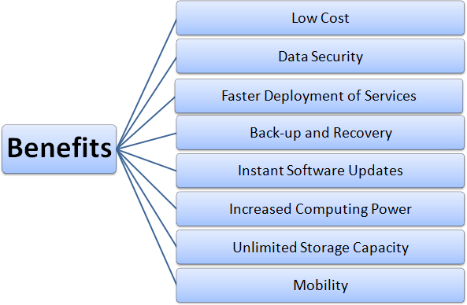

### Low Cost

* + - No need not to invest in larger numbers of powerful servers
    - Maintenance cost greatly reduces for both hardware and software maintenance for organizations.

### Data Security

* + - Cloud offers many advanced security features that guarantee that data is securely stored and handled.

### Faster Deployment of Services

* + - Cloud computing allows you to deploy your service quickly within fewer minutes.

### Back-up and recovery

* + - Once the data is stored in a Cloud, it is easier to get the back-up and recovery of the data

### Instant Software Updates

* + - If the app is web-based, updates happen automatically and are available next time when the user logs in to the cloud.

### Increased Computing Power

* + - The execution capacity of cloud servers is very high.
    - It processes the application very fast.

### Unlimited Storage Capacity

* + - Cloud offers huge amount of storage capacity

### Mobility

* + - Employees who are working on the premises or at the remote locations can easily access all the cloud services.

### Other Benefits

* + - On-Demand Self-service
    - Location and Device Independence
    - Always available
    - Scales automatically to adjust to the increase in demand
    - Allows pay-per-use

## Challenges

### Security and Privacy

* + - Security and privacy relate to the user data that is stored on cloud service providers (CSP) data centres.
    - The data centres must be secure and privacy of the data should be maintained by a CSP.

### Governance/Control

* + - In cloud computing, infrastructure resources are under CSP’s control and end-users or companies have to abide by the governance policies from CSP.
    - Traditional IT teams have no control over how and where their data is and processed.

### Compliance

* + - When organizations are moving their data to a cloud, they need to comply with particular policies, if the data is from public sources.
    - Finding a cloud provider who will comply with these policies is difficult to find.

### Computing Performance

* + - Cloud Computing is on-demand compute service and supports multi-tenancy, thus performance should not suffer over the acquisition of new users.
    - The CSP should maintain enough resources to serve all the users.

### Portability

* + - If the users want to migrate from one CSP to others, the vendor should not lock-in customer data

### Service Quality

* + - The service quality should be good and is a major concern of the end-user.

### Interoperability

* + - The application on one platform should be able to incorporate services from the other platform. This is known as Interoperability.
    - It is becoming possible through web services, but to develop such web services is complex.

### Availability and Reliability

* + - The data and service from CSP should be available at all times irrespective of the external conditions
    - Computing resources should be available for the users and their operability should be reliable.

# Unit 2 - Service and Deployment Models

* Cloud Computing Service Models: Infrastructure as a Service, Platform as a Service, Software as a Service;
* Cloud Computing Deployment Models: Private Cloud, Public Cloud, Community Cloud, Hybrid Cloud
* Major Cloud Service providers.

## Cloud Computing Models

* + Cloud computing has basically two types of models

### Service Models

* + - * Describe the type of service that the service provider is offering

### Deployment Models

* + - * Tell you where the cloud is located and for what purpose

1. **Service Models**
   * Based on the portfolio of services offered

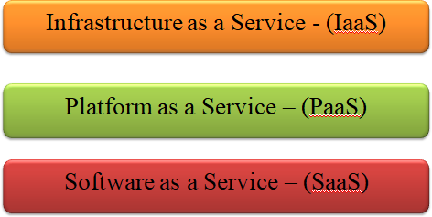

### Infrastructure as a Service (IaaS)

* + IaaS service provider provides virtual machines, virtual storage, virtual infrastructure, and other hardware assets as resources that clients can use.
  + IaaS eliminates the need for every organization to maintain the IT infrastructure.
  + Customers access these resources over internet on a pay-per-use model.
  + The client is responsible for all other aspects of the deployment. This can include the operating system, applications, and user interactions with the system.
  + Examples of IaaS service providers:
* Amazon Elastic Compute Cloud (EC2)
* GoGrid
* RackSpace Cloud
* Terremark

### Platform as a Service (PaaS)

* + PaaS provides virtual machines, operating systems, applications, services, development frameworks, transactions, and control structures.
  + PaaS cloud computing platform is a developer programming platform which is created for the programmer to develop, test, run and manage the applications.
  + A developer is able to write the application as well as deploy it directly into this layer easily.
  + PaaS extend and abstract the IaaS layer by removing the hassle of managing the individual virtual machine
  + Examples of PaaS services
* Force.com
* GoGrid CloudCenter
* Google AppEngine
* Windows Azure Platform

### Software as a Service (SaaS)

* + SaaS is a complete operating environment with applications, management, and the user interface.
  + Applications are hosted by a cloud service provider and made available to customers over internet.
  + Software and associated data are centrally hosted on the cloud server.
  + SaaS is accessed by users using a thin client via a web browser.
  + Examples of SaaS cloud service providers
* GoogleApps
* Oracle On Demand
* SalesForce.com
* SQL Azure

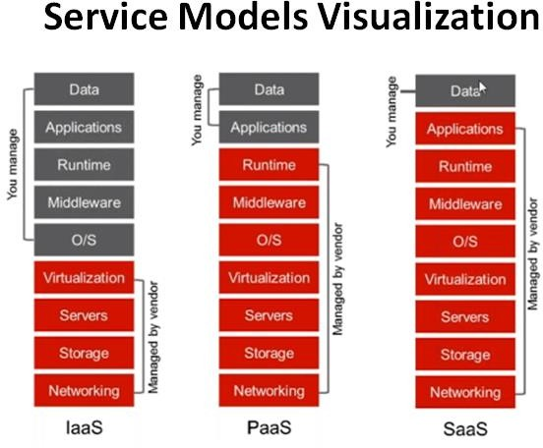

### Advantages of IaaS

* + You can dynamically choose a CPU, memory and storage configuration as per your needs.
  + You easily access the vast computing power available on IaaS cloud platform.
  + You can eliminate the need of investment in rarely used IT hardware.
  + IT infrastructure will be handled by the IaaS cloud computing vendors.

### Disadvantages of IaaS

* + There is a risk of IaaS cloud computing vendor by gaining the access to the organization’s data.
  + IaaS cloud computing model is dependent on internet availability.
  + IaaS cloud computing platform can limit the user privacy and customization options.

### Advantages of PaaS

* + **Simplified Development** :- Developers can focus on development and innovation without worrying about the infrastructure.
  + **Lower cost** :- No requirements of investment in hardware and software. Developers only need a PC and an internet connection to start building applications.
  + **Prebuilt business functionality** :- Some PaaS vendors also provide already defined business functionality so that users can avoid building everything from very scratch and hence can directly start the projects only.
  + **Instant community** :- PaaS vendors frequently provide online communities where developer can get the ideas, share experiences and seek advice from others.
  + **Scalability** :- Applications deployed can scale from one to thousands of users without any changes to the applications.

### Disadvantages of PaaS

* + **Vendor lock-in :-** One have to write the applications according to the platform provided by PaaS vendor so migration of an application to another PaaS vendor would be a problem.
  + **Data Privacy :-** There can be risk in terms of privacy of data.
  + **Integration with the rest of the systems applications :-** It may happen that some applications are local and some are in cloud. So there will be chances of increased complexity.

### Advantages of SaaS

* + **Easy to Buy :-** SaaS pricing is based on a monthly fee or annual fee, SaaS allows organizations to access business functionality at a low cost which is less than licensed applications.
  + **Less hardware required :-** Software is hosted remotely, so organizations don't need to invest in additional hardware.
  + **Low Maintenance :-** SaaS removes the necessity of installation, set-up, and maintenance for organizations.
  + **No special software or hardware versions required :-** All users will have the same version of software and typically access it through the web browser. SaaS reduces IT support costs by outsourcing hardware and software maintenance and support to the IaaS provider.

### Disadvantages of SaaS

* + **Security :-** Actually data is stored in cloud, so security may be an issue for some users.
  + **Latency issue :-** Because the data and application are stored in cloud at a variable distance from the end user, so there is a possibility that there may be more latency while interacting with the application than a local deployment. So, SaaS model is not suitable for applications whose response times are in milliseconds.
  + **Total Dependency on Internet:-** Without internet connection, most SaaS applications are not usable.
  + **Switching between SaaS vendors is difficult -** Switching SaaS vendors involves the difficult and slow task of transferring the very large data files over the Internet and then converting them into another SaaS also.

### Cloud Deployment Models

Deployment models tell you where the cloud is located and for what purpose

### Private cloud

* + - Enterprise owned or leased

### Public cloud

* + - Sold to the public, mega-scale infrastructure

### Community cloud

* + - Shared infrastructure for specific community

### Hybrid cloud

* + - composition of two or more types of clouds

### Private Cloud

* + A service provider makes resources, such as applications and storage available to **a limited number of people** behind firewall, minimizing security concerns
  + The Private cloud allows the accessibility of systems and services within the organization.
  + Private cloud gives companies direct control over their data.
  + It can be managed and hosted internally or by third party.

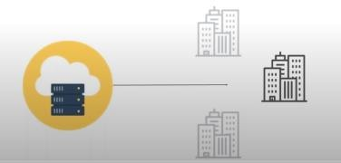

### Public Cloud

* + A service provider makes resources, such as applications and storage available to the general public over the internet
  + Easy and inexpensive setup.
  + No wasted resources because you pay for what you use.
  + It is constructed with a view to offer unlimited storage space and increased bandwidth via Internet to all Businesses.
  + These are owned, hosted and operated by third-party service providers.
  + 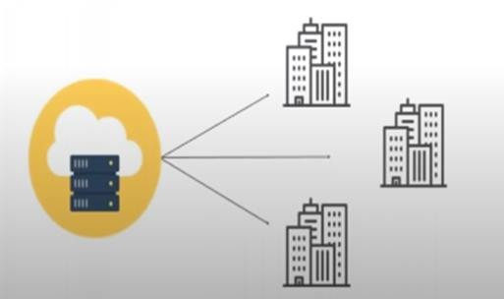It is based on “pay-as-you-go” model.

**Hybrid Cloud**

* + The Hybrid cloud is the mix of public and private cloud.
  + Non-critical activities are performed by public cloud while critical activities are performed by private cloud.
  + It has advantages of both private and public cloud, offer flexibility, control and security of multiple deployment models.
  + IT organizations use hybrid clouds to employ cloud bursting for scaling across clouds.

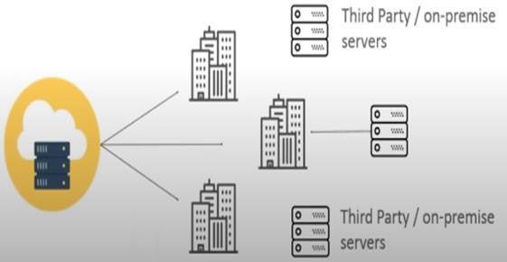

### Community Cloud

* + The cloud infrastructure is shared between the organizations having similar interests and requirements.
  + A community cloud is one where the cloud has been organized to serve a common function or purpose.
  + It can be managed and hosted internally or by a third party.

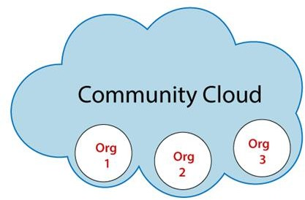

### Advantages of private cloud

* + **Enhanced security and privacy**
    - Private cloud can be isolated from all but the company who owns it.
    - This restricted access offers an additional layer of security.

### Improved reliability:

* + - Private cloud offers a greater degree of reliability.

### Improved performance:

* + - The resources within your private cloud infrastructure are at the disposal of your company alone.
    - There is no contention with other companies for capacity

### Total control:

* + - You are free to build and configure your private cloud in any way you like.

### Disadvantages of private cloud

* + **Restriction**
    - Private cloud is only accessible locally and it is very difficult to deploy globally.

### Higher Cost

* + - Cloud is having more cost than public clouds.

### Inflexible price

* + - In order to fulfill demands, purchasing new hardware is very costly.

### Less Scalability

* + - Private clouds are scaled only within capacity of internal hosted resources.

### Advantages of Public Cloud

* + **Low Cost**
    - Public cloud is having low cost as compared to private or hybrid cloud, because it shares same resources with large number of consumer.

### Reliable

* + - Public cloud provides large number of resources from different locations, if any of the resource fail, public cloud can employ another one.

### Location Independent

* + - It ensures the independency of location, because public cloud services are delivered through Internet.

### High Scalability

* + - Cloud resources are available as per the demand from the pool of resources that means they can be scaled up or down easily.

### Disadvantages of Public Cloud

* + **Low security**
    - In public cloud model, data is present off-site and resources are shared publicly. Hence it does not ensure the high level security.

### Less customizable

* + - It is less customizable than private cloud

### Lacks proper controls:

* + - The client has no control of data or infrastructure. There are issues of data privacy.

### Advantages of Hybrid Cloud

* + **Scalable**
    - It provides both the features of public and private cloud scalability.

### Flexible and Secure

* + - It provides secure resources because of private cloud and scalable resources because of public cloud.

### Cost effective

* + - It is having less cost as compared to private cloud.

### Disadvantages of Hybrid Cloud

* + **Networking Issues**
    - Networking becomes complex because of private and public cloud.

### Security Compliance

* + - It is necessary to ensure that cloud services are compliant with the security policies of an organization.

### Advantages of Community Cloud

* + **Cost effective**
    - Community cloud is cost effective because the whole cloud is shared between several organizations or a community.

### Flexible and Scalable

* + - The community cloud is flexible and scalable.

### Security

* + - Community cloud is more secure than the public cloud but less secure than the private cloud.

### Infrastructure Sharing

* + - Community cloud allows us to share cloud resources, infrastructure, and other capabilities among various organizations

### Disadvantages of Community Cloud

* + **Sharing Issues**
    - The fixed amount of data storage and bandwidth is shared among all community members.

### Higher cost

* + - Community Cloud is costly than the public cloud.

### Responsibility Issues

* + - Sharing responsibilities among organizations is difficult.

### Major Service Providers

**Amazon Web Services (AWS)**

* Amazon Web Services (AWS) is a giant that enables companies across the globe to develop their digital infrastructure entirely or partially using the cloud.

### Microsoft Azure

* Microsoft Azure is the closest competitor of cloud king AWS and it’s getting even closer. Microsoft emphasizes a lot of innovations to deliver exceptional services

### Google Cloud

* When Alphabet launched the Google Cloud Platform, the tech giant chose to target SMEs rather than go after established players, but now has major clients also.

### SalesForce

* The customers of SalesForce can use AI to recognize sales opportunities, which in turn, leads to more revenues.
* Another reason behind its enormous growth is the early mover advantage. It was the first company to start offering CRM in the cloud.

### IBM Cloud

* Some features that have attracted the businesses for IBM cloud include:
  + Open technologies that ensure interoperability
  + Powerful analytics system
  + Development solutions for enterprises

### Oracle Cloud

* Leading database software vendor, unveiled its ambitious program in the space of cloud computing in 2015.

Other cloud service providers are SAP, VMWare, Alibaba Cloud etc.

# Unit 3 - Service Level Agreement (SLA) Management

Overview of SLA, Types of SLA, SLA Life Cycle, SLA Management Process.

## Service Level Agreement (SLA)

* + SLA is a contract document or a formal negotiated agreement that exists between the Cloud Service Providers and the cloud users.
  + It includes the brief terms and conditions upon which the services being provided by the service providers.
  + SLA gives a transparent view to the cloud which includes the advantages and disadvantages of the cloud, security issues, responsibilities of the services etc.

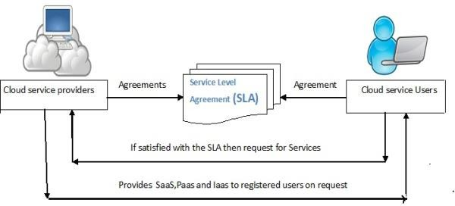

### Need of Using SLAs

* + It gives a clear idea about the cloud service providers.
  + It describes the list of services (SaaS, PaaS and IaaS) the providers will provide along with complete description of each service.
  + It is used to know about the key security and privacy management policies for cloud environment.
  + It monitors the service quality, performance, priorities, and responsibilities from service point of view.
  + It gives a transparent view to Know about the service management requirements in case of cloud service failure.
  + Service providers need SLAs to help them manage customer expectations and define the severity levels and circumstances under which they are not liable for outages or performance issues.
  + Customers can also benefit from SLAs because the contract describes the performance characteristics of the service -- which can be compared with other vendors' SLAs -- and sets forth the means for redressing service issues.

### Types of SLA

Service level agreements are also defined at different levels:

### Customer-based SLA:

* + - An agreement with an individual customer, covering all the services used by the customer.

### Service-based SLA:

* + - An agreement for all customers using the services being delivered by the service provider**.**

### Multilevel SLA

The SLA is split into the different levels, each addressing different set of customers for the same services, in the same SLA.

* + - **Corporate-level SLA**: Covering all the issues appropriate to every customer throughout the organization.
    - **Customer-level SLA**: Covering all the issues relevant to the particular customer group, regardless of the services being used.
    - **Service-level SLA**: Covering all the issues relevant to the specific services.

…………………………………………………………………………………………

There are two types of SLAs from the perspective of application hosting. (Note- second categorization of SLA)

### Infrastructure SLA

* + - The infrastructure provider manages and offers guarantees on availability of the infrastructure, namely, server machine, network connectivity, and son on.
    - Enterprises manage themselves their applications that are deployed on these server machines.
    - The machines are leased to the customers and are isolated from machines of other customers.

### Application SLA

* + - The server capacity is available to the applications based solely on their resource demands. Hence the service providers are flexible in allocating and de-allocating computing resources among the applications.

## Components of SLA

An ideal SLA has the following components:

### Purpose

* + - Mentions why SLA is formed.

### Parties

* + - Mentions the parties included in the SLA and their jobs.

### Validity Period

* + - States the time period covered by the SLA. This is defined by both the start time and the final time of the period.

### Scope

* + - Describes the services mentioned in the SLA

### Restrictions

* + - States the essential steps to be done in order to supply the required service levels.

### Service-level objectives –

* + - It contains a group of service level indicators such as; availability, performance, and reliability.

### Penalties

* + - describes what is to be done when the provider cannot achieve the goals in the SLA. If the SLA is taken with an external provider, there should be a choice of concluding the contract.

### Optional services

* + - services that are not ordinarily needed by the customer, but might be needed as exclusion.

### Exclusions

* + - states what is not included in the SLA.

## Life Cycle of SLA

* + Each SLA goes through a sequence of steps starting from:
    - Identification of terms and conditions,
    - Activation and monitoring of the stated terms and conditions
    - Termination of contract once the hosting relationship ends. Such a sequence of steps is called SLA life cycle.

It consists of the following five phases:

1. **Contract Definition**
2. **Publishing and Discovery**
3. **Negotiation**
4. **Operationalization**
5. **De-commissioning**

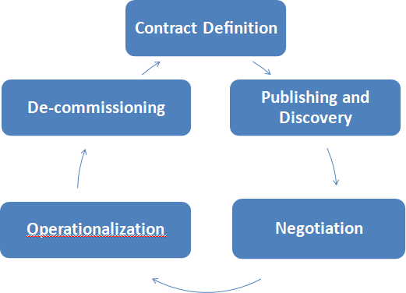

**Contract Definition**

* + Service provider defines a set of service offering and corresponding SLAs using standard templates.
  + These service offerings form a catalog.
  + Individual SLAs for enterprises can be derived by customizing these base SLA templates.

### Publication and Discovery

* + Service provider advertises these base service offerings through standard publication media
  + Customers should be able to locate the service provider by searching the catalog.
  + Customers can search different competitive offerings and shortlist a few that fulfill their requirements for further negotiation.

### Negotiation

* + Once the customer has discovered a service provider who can meet their application hosting need, the SLA terms and conditions need to be mutually agreed upon before signing the agreement for hosting the application.
  + For a standard packaged application which is offered as service, this phase could be automated.
  + For customized applications that are hosted on cloud platforms, this phase is manual.
  + At the end of this phase, the SLA is mutually agreed by both customer and provider and is eventually signed off.

### Operationalization

**SLA operation consists of**

* + - **SLA monitoring** involves measuring parameter values and calculating the metrics defined as a part of SLA.
    - **SLA accounting** involves capturing and archiving the SLA adherence for compliance. As part of accounting, the application’s actual performance and the performance guaranteed as a part of SLA is reported.
    - **SLA enforcement** involves taking appropriate action when the runtime monitoring detects a SLA violation.

### De-commissioning

* + SLA decommissioning involves termination of all activities performed under a particular SLA when the hosting relationship between the service provider and the service consumer has ended.
  + SLA specifies the term and conditions of contract termination and specifies situations under which the relationship between a service provider and a service consumer can be considered to be legally ended.

1. **SLA Management Process**

SLA management process of applications hosted on cloud platforms involves five phases.

1. **Feasibility**
2. **On-boarding**
3. **Pre-production**
4. **Production**
5. **Termination**

**Feasibility Analysis**

* Service Provider conducts the feasibility study of hosting an application on their cloud platforms. Feasibility study involves three kinds of feasibility:

### Technical feasibility

The need and availability of a specific hardware and software required for hosting and running of application.

### Infrastructure feasibility

It involves determining the availability of infrastructural resources in sufficient quantity so that the projected demands of the application can be met.

### Financial feasibility

It involves determining the approximate cost to be incurred by the project.

## On-boarding of Application

* Moving the application to the service provider hosting platform is called on-boarding
* On-boarding activity consists of the following steps:
  + Packing of the application for deploying on physical or virtual environments
  + The packaged application is executed directly on the physical servers to capture and analyze the application performance characteristics.
  + The application is executed on a virtualized platform and the application performance characteristics are noted again.
  + Based on the measured performance characteristics, different possible SLAs are identified.

## Preproduction

* + The application is hosted in a simulated production environment.
  + On successful completion of this phase, the service provider allows the application to go live.

## Production

* + In this phase, the application is made accessible to its end users under the agreed SLA.

## Termination

* + When the customer wishes to withdraw the hosted application and does not wish to continue to avail the services of the service provider for managing the hosting of its application, the termination activity is initiated