# Advanced IT(AIT)

* UNIT 2
* UNIT 3

# UNIT 2

Working with HTML

# List in HTML

* HTML Lists are used to specify lists of information. All lists may contain one or more list elements. There are three different types of HTML lists:
* Ordered List or Numbered List (<ol>)
* Unordered List or Bulleted List (<ul>)
* Description List or Definition List (<dl>)

# Ordered List/Numbered List

* In the ordered HTML lists, all the list items are marked with numbers by default. It is known as numbered list also. The ordered list starts with

<ol> tag and the list items start with <li> tag.

* **<ol>**
* **<li>**HTML**</li>**
* **<li>**CSS**</li>**
* **<li>**JS**</li>**
* **<li>**JAVA**</li>**
* **</ol>**

We can use ordered list to represent items either in numerical order format or alphabetical order format, or any format where an order is emphasized. There can be different types of numbered list:

* Numeric Number (1, 2, 3)
* Capital Roman Number (I II III)
* Small Roman Number (i ii iii)
* Capital Alphabet (A B C)
* Small Alphabet (a b c)

To represent different ordered lists, there are 5 types of attributes in <ol> tag

|  |  |
| --- | --- |
| Type | Description |
| Type "1" | This is the default type. In this type, the list items are numbered with numbers. |
| Type "I" | In this type, the list items are numbered with upper case roman numbers. |
| Type "i" | In this type, the list items are numbered with lower case roman numbers. |
| Type "A" | In this type, the list items are  numbered with upper case letters. |
| Type "a" | In this type, the list items are numbered with lower case letters. |

# Example i/p n o/p

<!DOCTYPE html>

<html>

<body>

<ol>

<li>HTML</li>

<li>Java</li>

<li>JavaScript</li>

<li>SQL</li>

</ol>

</body>

</html>

1. HTML
2. Java
3. JavaScript
4. SQL

# Other attributes

**Start Attribute:** The start attribute is used with <ol> tag to specify from where to start the list items.

* + **<ol type="1" start="5">** : It will show numeric values starting with "5".
  + **<ol type="A" start="5">** : It will show capital alphabets starting with "E".
  + **<ol type="a" start="5">** : It will show lower case alphabets starting with "e".
  + **<ol type="I" start="5">** : It will show Roman upper case value starting with "V".

**reversed Attribute:**

This is a Boolean attribute of HTML <ol> tag, and it is new in HTML5 version. If you use the reversed attribute with tag then it will numbered the list in descending order (7, 6, 5, 4......1). Here is example:

<!DOCTYPE html>

<html>

<head>

</head>

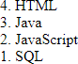<body>

<ol reversed>

<li>HTML</li>

<li>Java</li>

<li>JavaScript</li>

<li>SQL</li>

</ol>

</body>

</html>

**Unordered List** or Bulleted List

* + **HTML Unordered List** or Bulleted List displays elements in bulleted format . We can use unordered list where we do not need to display items in any particular order. The HTML <ul> tag is used for the unordered list. There can be 4 types of bulleted list:
  + disc
  + circle
  + square
  + none
  + To represent different ordered lists, there are 4 types of attributes in <ul> tag.

|  |  |
| --- | --- |
| Type | Description |
| Type "disc" | This is the default style. In this style, the list items are marked with bullets. |
| Type "circle" | In this style, the list items are marked with circles. |
| Type "square" | In this style, the list items are marked with squares. |
| Type "none" | In this style, the list items are not  marked . |

## Example:

<!DOCTYPE html>

<html>

<body>

<h1> Here is an example of unordered list</h1>

<ul>

<li>HTML</li>

<li>Java</li>

<li>JavaScript</li>

<li>SQL</li>

</ul>

</body>

</html>

Output:

**Here is an example of unordered list**

* + - HTML
    - Java
    - JavaScript
    - SQL

Note: by default unordered list type is disc.

Other you can try using type attribute in <ul> tag

# Description list/Definition list

* + - **HTML Description List** or Definition List displays elements in definition form like in dictionary. The <dl>, <dt> and <dd> tags are used to define description list.
    - The 3 HTML description list tags are given below:
    - **<dl> tag** defines the description list.
    - **<dt> tag** defines data term.
    - **<dd> tag** defines data definition (description).

## Example

<!DOCTYPE html>

<html>

<body>

<p><b>Here is an example of Description/ Definition List in HTML</b></p>

<dl>

<dt>HTML</dt>

<dd>is a markup language and develpoed by Tim Berners lee in 1992</dd>

<dt>Java</dt>

<dd>is a programming language and platform Independent</dd>

<dt>JavaScript</dt>

<dd>is a scripting language</dd>

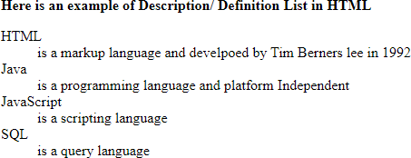<dt>SQL</dt>

<dd>is a query language</dd>

</dl>

</body>

</html>

## Working with Image

* **HTML <img> tag** is used to display image on the web page. HTML <img> tag is an empty tag that contains attributes only, closing tags are not used in HTML image element.

Attributes of HTML img tag

* The src and alt are important attributes of HTML img tag. All attributes of HTML image tag are given in next slide:

**src:** It is a necessary attribute that describes the

source or path of the image. It instructs the browser where to look for the image on the server.

The location of image may be on the same directory or another server.

**alt:** The alt attribute defines an alternate text for the image, if it can't be displayed.

Image Size - Width and Height: use style attribute to specify the width and height of an image.

Example

<img src="img_flower.jpg" alt=“Pink

Flower" style="width:500px; height:600px;">

Alternatively, the width and height attributes can be used as given below:

Example

* + <img src="img_flower.jpg" alt=“Pink Flower" width="500" height="600">
  + The width and height attributes always define the width and height of the image in pixels.
* Other attributes are:

1. Border
2. Hspace
3. Vspace
4. Align(left, center, right)

<!DOCTYPE html>

<html>

<body>

<p>Use image tag in HTML along with all the attributes</p>

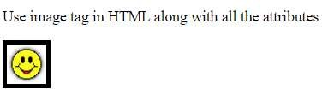<img src="smiley.gif" alt="Smiley face" width="42" height="42" style="border:5px solid black">

</body>

</html>

## Working with Links

* **HTML anchor tag** defines *a hyperlink that links one page to another page*. It can create hyperlink to other web page as well as files, location, or any URL. The "href" attribute is the most important attribute of the HTML <a> tag which links to destination page or URL.

**href attribute:** The href attribute is used to define the address of the file to be linked. In other words, it points out the destination page.

The syntax of HTML anchor tag is given below.

* <a href = "..........."> Link Text </a>
* **target attribute:** By default, the linked page will be displayed in the current browser window. To change this, you must specify another target for the link.
* The target attribute specifies where to open the linked document.
* The target attribute can have one of the following values:

_self: Default. Opens the document in the same window/tab as it was clicked

_blank: Opens the document in a new window or tab

_parent: Opens the document in the parent frame

_top: Opens the document in the full body of the window

<!DOCTYPE html>

<html>

<body>

<h2>The anchor tag along with href and target Attribute</h2>

<a href="https://[www.youtube.com/"](http://www.youtube.com/) target="_blank">Visit youtube!</a>

<p>If target="_blank", the link will open in a new browser window or tab.</p>

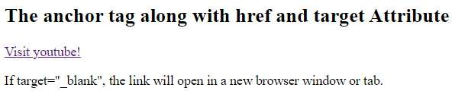</body>

</html>

**Absolute URLs vs. Relative URLs**

A local link (a link to a page within the same website) is specified with a **relative URL** (without the "https://www" part):

Example:

* External Linking

<h2>Absolute URLs</h2>

<p><a href="http[s://www.w3.org/">W](http://www.w3.org/)3C</a></p>

<p><a href="http[s://www.google.com/">Google</](http://www.google.com/)a></p>

* Internal Linking

<h2>Relative URLs</h2>

<p><a href="html_images.asp">HTML Images</a></p>

<p><a href="/css/default.asp">CSS Tutorial</a></p>

# Unit 3

Designing with HTML

## Creating Tables

* **HTML table tag** is used to display data in tabular form (row * column). There can be many columns in a row.
* We can create a table to display data in tabular form, using <table> element, with the help of <tr> , <td>, and <th> elements.
* In Each table, table row is defined by <tr> tag, table header is defined by <th>, and table data is defined by <td> tags.

|  |  |
| --- | --- |
| Tag | Description |
| **<table>** | It defines a table. |
| **<tr>** | It defines a row in a table. |
| **<th>** | It defines a header cell in a table. |
| **<td>** | It defines a cell in a table. |
| **<caption>** | It defines the table caption. |
| **<tbody>** | It is used to group the body content in a table. |
| **<thead>** | It is used to group the header content in a table. |
| **<tfooter>** | It is used to group the footer content in a table. |

## Important table tags

**<table>**: It defines a table.

**<tr>**: It defines a row in a table.

**<th>**: It defines a header cell in a table.

**<td>**: It defines a cell in a table.

**<caption>**: It defines the table caption.

**<tbody>**: It is used to group the body content in a table.

**<thead>**: It is used to group the header content in a table.

**<tfooter>**: It is used to group the footer content in a table.

HTML Table example

<!DOCTYPE>

<html>

<body>

<!-- here is step 1 of table formation-->

<table>

<caption><b>Student_Info</b></caption>

<tr><th>First_Name</th><th>Last_Name</th><th>Marks</th></tr>

<tr><td>Abay</td><td>Singh</td><td>95</td></tr>

<tr><td>Jatin</td><td>Singh</td><td>85</td></tr>

<tr><td>Ankush</td><td>Kumar</td><td>87</td></tr>

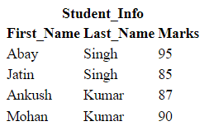<tr><td>Mohan</td><td>Kumar</td><td>90</td></tr>

</table>

</body>

</html>

### HTML Table with Border

There are two ways to specify border for HTML tables.

1. By border attribute of table in HTML
2. By border property in CSS
   1. HTML Border attribute: Use border attribute of table tag in HTML to specify border. But it is not recommended now.
   2. CSS Border property: It is now recommended to use border property of CSS to specify border in table.

<!DOCTYPE>

<html>

<body>

<!-- Step 2 -->

<table border="1">

<caption><b>Student_Info</b></caption>

<tr><th>First_Name</th><th>Last_Name</th><th>Marks</th></tr>

<tr><td>Abay</td><td>Singh</td><td>95</td></tr>

<tr><td>Jatin</td><td>Singh</td><td>85</td></tr>

<tr><td>Ankush</td><td>Kumar</td><td>87</td></tr>

<tr><td>Mohan</td><td>Kumar</td><td>90</td></tr>

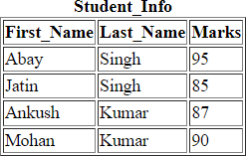</table>

</body>

</html>

<!DOCTYPE>

<html>

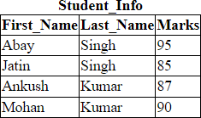<head>

<style> table, th, td {

border: 1px solid black; border-collapse: collapse;

}

</style>

</head>

<body>

<table border="1">

<caption><b>Student_Info</b></caption>

<tr><th>First_Name</th><th>Last_Name</th><th>Marks</th></tr>

<tr><td>Abay</td><td>Singh</td><td>95</td></tr>

<tr><td>Jatin</td><td>Singh</td><td>85</td></tr>

<tr><td>Ankush</td><td>Kumar</td><td>87</td></tr>

<tr><td>Mohan</td><td>Kumar</td><td>90</td></tr>

</table>

</body>

</html>

### HTML Cell Padding & Cell Spacing:

HTML tables can adjust the padding inside the cells, and also the space between the cells using cellspacing and cellpadding attributes of <table> tag.

|  |  |  |
| --- | --- | --- |
| With Padding | | |
| hello | hello | hello |
| hello | hello | hello |
| hello | hello | hello |

|  |  |  |
| --- | --- | --- |
| With Spacing | | |
| hello | hello | hello |
| hello | hello | hello |
| hello | hello | hello |

Other attributes of <table> tag are given below:

* Bordercolor
* Bgcolor
* Align
* Height
* Weight

## rowspan and colspan

HTML tables can have cells that span over multiple rows and/or columns.

colspan: To make a cell span over multiple columns, use the colspan attribute. The value of the colspan attribute represents the number of columns to span.

rowspan: To make a cell span over multiple rows, use the rowspan attribute. The value of the rowspan attribute represents the number of rows to span.

<!DOCTYPE html>

<html>

<head>

<style> table, th, td {

border: 1px solid black;

## Example of colspan

<tr>

<td>Abay</td>

<td>Singh</td>

<td>47</td>

</tr>

<tr>

border-collapse: collapse;

}

</style>

</head>

<body>

<h2>Cell that spans two columns</h2>

<p>To make a cell span more than one column,

use the colspan attribute.</p>

<table style="width:100%">

<tr>

<th colspan="2">Name</th>

<th>Age</th>

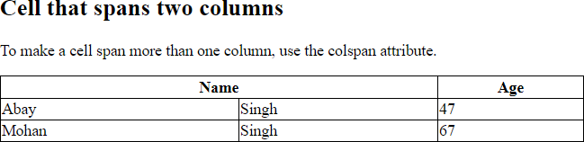</tr>

<td>Mohan</td>

<td>Singh</td>

<td>67</td>

</tr>

</table>

</body>

</html>

Output:

<!DOCTYPE html>

<html>

<head>

<style>

table, th, td {

## Example of rowspan

<tr>

<th>Name</th>

<td>Mohan</td>

</tr>

<tr>

border: 1px solid black; border-collapse: collapse;

}

</style>

</head>

<body>

<h2>Cell that spans two rows</h2>

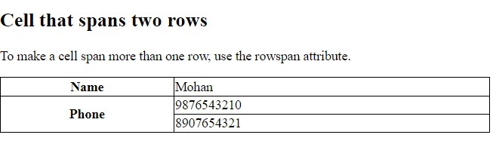<p>To make a cell span more than one row, use the rowspan attribute.</p>

<table style="width:100%">

<th rowspan="2">Phone</th>

<td>9876543210</td>

</tr>

<tr>

<td>8907654321</td>

</tr>

</table>

</body>

</html>

## Working with frames

HTML frames are used to divide your browser window into multiple sections where each section can load a separate HTML document.

A collection of frames in the browser window is known as a frameset. The window is divided into frames in a similar way the tables are organized: into rows and columns.

To use frames on a page we use <frameset> tag

instead of <body> tag.

The <frameset> tag defines, how to divide the window into frames.

The **rows** attribute of <frameset> tag defines horizontal frames and **cols** attribute defines vertical frames. Each frame is indicated by

<frame> tag and it defines which HTML document shall open into the frame.

<!DOCTYPE html>

<html>

<head>

<title>HTML Frames</title>

</head>

<frameset rows = "10%,80%,10%">

**<!– at the place of rows we can use cols are well…Try this in Lab-->**

<frame name = "top" src = "/html/top_frame.htm" />

<frame name = "main" src = "/html/main_frame.htm" />

<frame name = "bottom" src = "/html/bottom_frame.htm" />

<noframes>

<body>Your browser does not support frames.</body>

</noframes>

</frameset>

</html>

**Note:** The <frame> tag deprecated in HTML5. So instead of using <frame> we can use the concept of <iframe >.

## HTML Form

HTML forms are required if you want to collect some data from of the site visitor.

For example: If a user want to purchase some items on internet, want to fill the form, shipping address and credit/debit card details so that item can be sent to the given address.

|  |  |
| --- | --- |
| Tag | Description |
| <form> | It defines an HTML form to enter inputs by the used side. |
| <input> | It defines an input control. |
| <textarea> | It defines a multi-line input control. |
| <label> | It defines a label for an input element. |
| <legend> | It defines a caption for a <fieldset> element. |
| <button> | It defines a clickable button. |

* HTML <form> element
* The HTML <form> element provide a document section to take input from user. It provides various interactive controls for submitting information to web server such as text field, text area, password field, etc.

Note: The <form> element does not itself create a form but it is container to contain all required form elements, such as <input>, <label>, etc.

**Syntax:**

**<form>**

//Form elements

**</form>**

HTML <input> element

* The HTML <input> element is fundamental form element. It is used to create form fields, to take input from user. We can apply different input filed to gather different information form user. Following is the example to show the simple text input.

Example:

**<body>**

**<form>**

Enter your name **<br>**

**<input** type="text" name="username"**>**

**</form>**

**</body>**

An <input> element can be displayed in many ways, depending on the type attribute given in next slide.

|  |  |
| --- | --- |
| Type | Description |
| <input type="text"> | Displays a single-line text input field |
| <input type="radio"> | Displays a radio button (for selecting one of many choices) |
| <input type="checkbox"> | Displays a checkbox (for selecting zero or more of many choices) |
| <input type="submit"> | Displays a submit button (for submitting the form) |
| <input type="button"> | Displays a clickable button |

Other permissible values in type attribute are given below:

* <input type="color">
* <input type="date">
* <input type="email">
* <input type="file">
* <input type="number">
* <input type="password">
* <input type="search">
* <input type="time">
* <input type="url">
* <input type="week">

**The <label> Element**

* The <label> element is useful for screen-reader users, because the screen-reader will read out loud the label when the user focuses on the input element.
* The <label> element also helps users who have difficulty clicking on very small regions (such as radio buttons or checkboxes) - because when the user clicks the text within the <label> element, it toggles the radio button/checkbox.
* The for attribute of the <label> tag should be equal to the id attribute of the <input> element to bind them together.

<!DOCTYPE html>

<html>

<head>

<body>

<h2>Use Html form and create a form with First Name and Last Name</h2>

<p>For this use label n input tags along with suitable attributes and make a form more attractive. </p>

<form>

<label for="firstname">First Name: </label>

<input type="text" id="firstname" name="firstname"/>

<br/>

<br/>

<label for="lastname">Last Name: </label>

<input type="text" id="lastname" name="lastname"/> <br/>

</form>

</body>

</html>

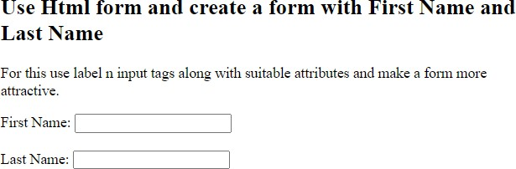

<!DOCTYPE html>

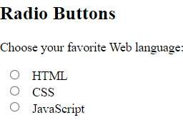<html>

<body>

<h2>Radio Buttons</h2>

<p>Choose your favorite Web language:</p>

<form>

<input type="radio" id="html" name="fav_language" value="HTML">

<label for="html">HTML</label><br>

<input type="radio" id="css" name="fav_language" value="CSS">

<label for="css">CSS</label><br>

<input type="radio" id="javascript" name="fav_language" value="JavaScript">

<label for="javascript">JavaScript</label>

</form>

</body>

</html>

**Note:** Try checkboxes in Lab